RMU Public Speaking and Persuasion/Talerico—SU18
Speech 3—My Favorite Movie

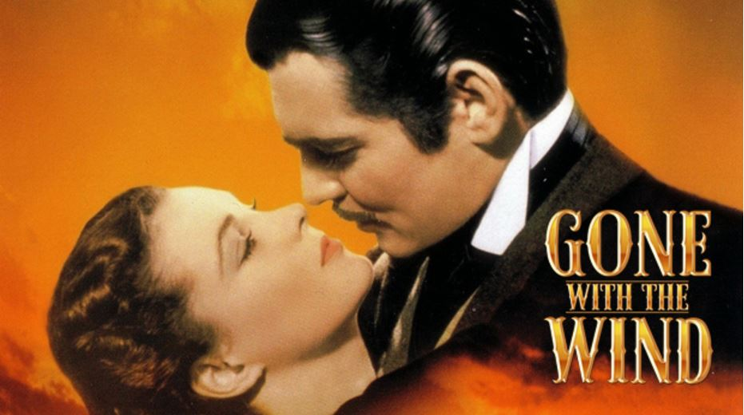
For your third and final speech, you will talk about your favorite movie—and the reasons why you like it.

Many of us have a lot of favorite movies, so it may be hard to pick just one—but just be sure it is one you are passionate about. Select only one movie—not a series.

Writing the Thesis and Outline
Some of the reasons a movie may be your favorite—and these would make up your thesis statement—are the following:

- the director  - the actors  - the theme  - the plot (but don't tell us everything—don't spoil movie)  - a particular outstanding scene/s  - the genre (drama, thriller, comedy)  - soundtrack/music | - the writing  - the awards won  - the reception/critics  - the cultural impact/influence  - the background (how movie was made, conflicts behind scenes, interesting facts, etc.)  - mistakes (any mistakes in the movie?)

Sources
Along with the movie itself, you need at least three other sources, which could include movie reviews or information about the actors, writers and director. At least two of the sources must be mentioned in your speech presentation (oral footnotes). These sources should be incorporated in the first draft of your preparation outline. Your bibliography must be annotated and in APA format. This means that on your References page you will not only cite the sources but also include a four- to five-sentence summary of the content of the source and how it was useful in your research and writing. This summary must be in your own voice and words. (See sample in this packet.)

Visual Aid
You should plan to show an excerpt from the movie, and this should not exceed one to two minutes. If you wish, you can show a few scenes, but, again, the total time for this should not exceed two minutes. Keep in mind that if you plan to show a couple of video clips, you need to have the clips prepared beforehand. You cannot take time during the presentation to look for the excerpts. Out of respect for your audience, the clips should not be sexually explicit, overly violent, or contain profanity.

Do not show the movie’s entire trailer. These are too long, and they preview the entire film, which takes your speech off topic. It is best to have a specific excerpt or two.
You also will need to have a simile or metaphor for this speech. This must be created by you and not come from the movie or another author.

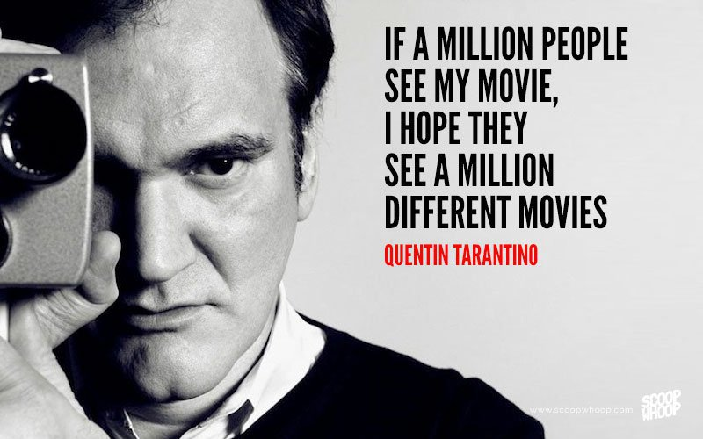
Preparation Outline
The outline should be typed, single-spaced (but double-spaced between points) and not exceed two pages. (See template included in this packet).

The first draft of the preparation outline is due next week in class. This is worth 10 points. If you do not have the outline in hard copy in class that day, it is worth 0 points.

After the peer review, you will write a revised, final draft of the preparation outline. Then, you will create your presentation outline, which you will use when delivering the speech.

Presenting the Speech
The speeches will be presented in two weeks (the week of July 23). If you miss your speaking date, you will lose 20 percent of the points off the top. In addition, there may not be time for you to make up the speech, thus forfeiting the 70 points. In addition to giving your speech, you will hand in four documents: your revised preparation outline, presentation outline, rhetorical devices sheet, and References. These documents must be handed in in hard copy the day of your presentation; otherwise, they are worth 0 points.

Speech 3 Total Points—120 points
- Preparation Outline 1 10 points
- Preparation Outline final draft 10 points
- Presentation Outline 10 points
- Rhetorical Devices Sheet 10 points
- References 10 points
- Speech Presentation 70 points
TOTAL 120 points

RMU Public Speaking and Persuasion/Talerico
Speech 3 Rubric—Favorite Movie Speech

Speaker ___________________________________ Topic ____________________________

Introduction _____ (10) COMMENTS
_____ Starts with a smile (2)
_____ Starts with good volume and energy—loud and clear (2)
_____ Makes clear why this movie was selected (ethos) (2)
_____ Effectively engages audience from the start (2)
_____ Gives a brief overview of movie and sets up the thesis well (2)
Thesis _____ (6)
_____ States three-five main points (3)
_____ States slowly and clearly (3)

Body _____ (18)
_____ Signposting and main points are clear (easy to follow) (2)
_____ Main points have balance (3)
_____ Main points have sufficient supports (3)
_____ Movie plot summary clearly explained (without spoiler!) (4)
_____ Simile or metaphor is used (2) ________________________________________________________
_____ First oral source—(spoken slowly and clearly) (2) _________________________________________
_____ Second oral source—(spoken slowly and clearly) (2) _______________________________________

Delivery _____ (20)
_____ Speech is not read/speaker doesn’t depend on notes (3)
_____ Speaker obviously practiced the speech (3)
_____ Eye contact is good–looks at entire room equally (3)
_____ Volume is loud and clear (no mumbling) (3)
_____ Pace is good—speaker doesn’t rush (3)
_____ Emotion and passion are effectively used—speaker moves audience (3)
_____ At least one line delivered in a different way (emphasis/enthusiasm) (2)
Visual Aid _____ (6)
_____ No more than two minutes’ total of movie is shown (3)
_____ Clip/s are set up well, in good taste, and enhance (not distract from) speech (3)
Conclusion _____ (10)
_____ Prepares audience for the ending–not abrupt (2)
_____ Summarizes thesis/speech clearly (not verbatim) (2)
_____ Is substantial—leaves audience with food for thought (2)
_____ Successfully informs audience (2)
_____ Audience is now excited about the movie as well (2)
Total Points ________/70 Scale: A–70-63 B–62-56 C–55-49 D–48-42 F–41-0
(The revised preparation outline, presentation outline, References, and rhetorical elements sheet
are due the day of your speech presentation.)

Speech 3 Preparation Outline Worksheet/Template

Name
Class
Date
Assignment (SP3-Prep. OL1)

Speech Title: (5 to 8 words—should be captivating)

Introduction (select two)
Identifying with the Audience, Identifying with the Occasion, Stating the Purpose, Stating Important of Topic, Startling Statistic, Narration, Analogy, Rhetorical Question, Quotation, Humor

I. Type of Introduction 1: (one sentence summary/explanation)
II. Type of Introduction 2: (one sentence summary/explanation)

II. Type of Introduction 3: (one sentence summary/explanation)
IV. Movie summary (but be careful not to spoil ending)
V. Why you selected this movie.
Thesis: One sentence with your three (or more) main points.
Thesis
This is the main idea of your speech, and it usually includes three points. Put in one sentence:
Body
I. First, (one sentence—first point of thesis).
A. (One sentence).

B. (One sentence).

C. (One sentence).

II. Second, (one sentence—second point of thesis).
A. (One sentence).

B. (One sentence).

C. (One sentence).

III. Finally, (one sentence—third point of thesis).
A. (One sentence).

B. (One sentence).
C. (One sentence).

Conclusion (select two)
Summarizing, Narration, Rhetorical Question, Quotation, Personal Reference, Humor, Warning, Remedy,
The Challenge, Call to Action, The Inspiration, Utopian Vision

I. Type of Conclusion 1: (one sentence summary/explanation)
II. Type of Conclusion 2: (one sentence summary/explanation)

III. Type of Conclusion 3: (one sentence summary/explanation)

Note the following—the outline should:
- be typed and double-spaced between points (not every line)
- not exceed two pages
- include the two sources that will be your oral footnotes (put the sources before quote/information)
- analyze the movie in present tense, as you would do in literature
- have clear, simple sentences (don’t overload sentences)
- have one point per sentence

10 Types of Introductions | Identifying with the Audience, Identifying with the Occasion, Stating the Purpose, Stating the Important of the Topic, Startling Statistic, Narration, Analogy, Rhetorical Question, Quotation, Humor
11 Types of Conclusions | Summarizing, Narration, Rhetorical Question, Quotation, Making a Personal Reference, Warning, Remedy, The Challenge, Call to Action, Utopian Vision, The Inspiration
11 Writing Strategies | Narration, Description, Illustration, Process, Definition, Classification, Comparison/Contrast, Argumentation, Cause and Effect, Reporting, Evaluating
7 Supporting Strategies | Personal Experience, Common Knowledge, Direct Observation, Examples (brief, hypothetical, anecdote), Documents, Statistics (rates of change, experiments), Testimony (factual and opinion)
8 Types of Supporting Materials | Memory, Interviews, Books, Reference Works, Periodicals (general, special, technical), Newspapers, Government Publications, Electronic Supporting Materials
9 Stylistic Techniques | Signposting, Parallelism, Antithesis, Alliteration, Metaphor, Simile, Gestures, Smile, Vocal Inflection  (not monotone)

RMU/Public Speaking and Persuasion/Talerico
Speech 3 Rhetorical Devices Sheet
(Type in your responses here—or print neatly)

Your Name: ____________________________________________________________

Credibility: (Why are you giving this speech? This must be stated in the introduction.)
___________________________________________________________________________
___________________________________________________________________________

___________________________________________________________________________

Emphasis Line: (What line in your speech will you intentionally deliver in a different way?)

___________________________________________________________________________
___________________________________________________________________________

___________________________________________________________________________

Pathos: (What will you say that will make us feel something, that will move us?)

___________________________________________________________________________
___________________________________________________________________________

___________________________________________________________________________

Passion: (What can you do to deliver the speech with volume, energy and passion?)

___________________________________________________________________________
___________________________________________________________________________

___________________________________________________________________________

Simile/Metaphor: (What comparison will you make in a vivid way that will impact our senses?)

___________________________________________________________________________
___________________________________________________________________________

___________________________________________________________________________

Research Source List
This is a worksheet designed to help you write your Works Cited page. Do not hand in this sheet, but type up a formal, double-spaced annotated References page in APA format.

Source one: (Cite the Movie)
Name or title of source:

What is the source about (2 sentences):
How would you evaluate the source—fair, effective, biased, unbiased, thorough, etc. (1 sentence):

Where do you plan to use the source in your paper (1 sentence):
Format for Movie Citation:
Producer, P. P. (Producer), & Director, D. D. (Director). (Date of publication). Title of motion picture
[Motion picture]. Country of origin: Studio or distributor.

Source two:
Name or title of source:

What is the source about (2 sentences):
How would you evaluate the source—fair, effective, biased, unbiased, thorough, etc. (1 sentence):

Where do you plan to use the source in your paper (1 sentence):

Source three:
Name or title of source:

What is the source about (2 sentences):
How would you evaluate the source—fair, effective, biased, unbiased, thorough, etc. (1 sentence):

Where do you plan to use the source in your paper (1 sentence):

Source four:
Name or title of source:

What is the source about (2 sentences):
How would you evaluate the source—fair, effective, biased, unbiased, thorough, etc. (1 sentence):

Where do you plan to use the source in your paper (1 sentence):

Sample Annotated References Page in APA

An annotated bibliography (or References page) includes a summary and/or evaluation of each of the sources you have used. The annotation is approximately four sentences and should include these three elements:

- Summarize the source: tell what it is about (2 sentences)
- Assess the source: tell the value of the source, if it was, for example, useful, reliable, scholarly, biased, etc. (1 sentence)
- Reflect on the source: tell how you used the source in your essay (1 sentence)

References

Lamott, Anne. (1995). Bird by Bird: Some Instructions on Writing and Life. New York: Anchor Books,

Lamott's book offers honest advice on the nature of a writer’s life, complete with its insecurities
and failures. Lamott’s writing is wry and anecdotal, and she gives advice on everything from
crafting a speech to struggling with one's own internal critic. Because she is a well-known author,
her points reflect her experiences and, therefore, are subjective but highly credible.
I used a quote from her book for the introduction of my speech.

